public static DataTable CreateDT()

{

DataTable dt = new DataTable();

dt.Columns.Add("Manager", typeof(string));

dt.Columns.Add("Employee", typeof(string));

dt.Columns.Add("Verizon", typeof(string));

dt.Columns.Add("StarrID", typeof(string));

return dt;

}

private DataTable JoinTables(DataTable dt2, DataTable dt1)

{

var dtJoin = (from p in dt1.AsEnumerable()

join t in dt2.AsEnumerable()

on p.Field<string>("StarrID") equals t.Field<string>("StarrID")

select new

{

Manager = p.Field<string>("Manager"),

Verizon = t.Field<string>("EmplID"),

EmpName = p.Field<string>("Employee"),

StarrID = p.Field<string>("StarrID")

}).ToList();

DataTable dtFit = DataAccess.CreateDT();

foreach (var item in dtJoin)

{

string f1 = item.Manager;

string f2 = item.EmpName;

string f3 = item.Verizon;

string f4 = item.StarrID;

dtFit.Rows.Add(f1, f2, f3, f4);

}

return dtFit;

}

Nota: Importante, dara problema el AsEnumerable si no incluye:

* System.Data.DataSetExtensions
* System.Data
* System.Linq

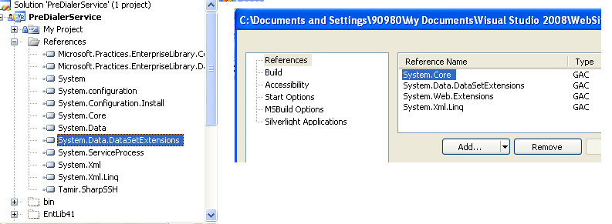

 Example

The following example performs a traditional join of the *SalesOrderHeader* and *SalesOrderDetail* tables from the AdventureWorks sample database to obtain online orders from the month of August.

// Fill the DataSet.

var query =

from order in orders.AsEnumerable()

join detail in details.AsEnumerable()

on order.Field<int>("SalesOrderID") equals detail.Field<int>("SalesOrderID")

where order.Field<bool>("OnlineOrderFlag") == true

&& order.Field<DateTime>("OrderDate").Month == 8

select new

{

SalesOrderID = order.Field<int>("SalesOrderID"),

SalesOrderDetailID = detail.Field<int>("SalesOrderDetailID"),

OrderDate = order.Field<DateTime>("OrderDate"),

ProductID = detail.Field<int>("ProductID")

};

foreach (var order in query)

{

Console.WriteLine("{0}\t{1}\t{2:d}\t{3}",

order.SalesOrderID,

order.SalesOrderDetailID,

order.OrderDate,

order.ProductID);

}